Geography
Task #1: World Map (Use google!)
- Can you find Afghanistan?
Once you have found it, circle and label it

- How far is Afghanistan from Clinton Township? ________________
Task #2: Map of Afghanistan (Use google!)
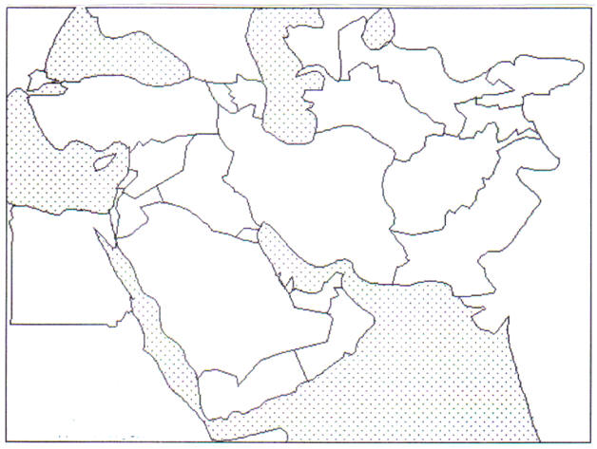
- Label the following places on the map below (Include Kabul, Kandahar, Turkmenistan, Uzbekistan, Tajikistan, India, Iran, Pakistan, and China)

- What is the capital city of Afghanistan?

- What countries border Afghanistan?

War and Politics

Task #3: TheTaliban (Google)
- What is the Taliban and where are they?

- What does Taliban mean in Pashto?

- Which famous terrorist are the Taliban accused of helping?

People -https://www.cia.gov/library/publications/the-world-factbook/geos/af.html

Task #4: Language (People and Society)
- What percent of males are literate?
- What percent of females are literate?

- Afghanistan is a very diverse country with a number of different ethnic and linguistic groups. However, what are the two official languages of Afghanistan?

- Write your name in Dari. http://mylanguages.org/dari_write.php
Task #5: Religion
- What is the main religion in Afghanistan?

- What percent of people follow this religion?
Task #6: Clothing and Food (Google)
There are many different kinds of veils in the Islamic world. Write a definition for hijab, chador, and burqa.
- Hijab-

- Chador-

- Burqa-

- Describe a shalwar kameez.

- What is Eid?

- What kind of food is naan?

Task #7: Women
http://www.rawa.org/rules.htm

- What can happen to a woman not wearing a burqa?

- Why must all windows be painted?

- Can women be photographed? YES NO
- Can their picture be shown? YES NO

- List three additional restrictions that women face.
a.

b.

c.

- List three additional restrictions that apply to both men and women.

Task #8 History of Afghanistan https://www.factmonster.com/taliban-timeline-3
What happened in the following years?
1979-________________________ invades Afghanistan.
1988-Soviet troops __________________.
1994-The ______________ ("religious students") are appointed by ______________ to protect a trade convoy and quickly emerge as one of the strongest factions.
1996- The Taliban, under the leadership of Mullah Muhammad Omar, seize control of____________ and implement a strict interpretation of ________________law. They exile President Rabbani and __________________ Najibullah. The Taliban offer _____________________________ refuge.

1998-The U.S. launches _____________________at suspected bin Laden bases in retaliation for the bombing of embassies in Africa.
1999-The Taliban take Mazar-i-Sharif. There are unconfirmed reports of mass _____________ and __________________(numbering in the thousands) of Shiites, especially of the Hazara ethnic group.
2000- Record cold, drought, and civil war push an estimated 200,000 more Afghans into _______________.
2001- Taliban bans the use of the ___________, playing cards, computer discs, ___________, satellite TV, musical instruments, and chessboards, after declaring them against Islamic law.
September 11: Terrorist attack on__________________________________________________.
Mid September: U.S. demands that the Taliban hand over bin Laden and __________________ members.
Scroll through the next 10 years and record 3 violent attacks that the Taliban are responsible for.
1.

2.

3.

